**Assignment 21.3**

**Problem Statement:**

This dataset consists of two columns i,e., first_name & last_name &city use custom input format to read the key as the combination of first_name and last_name and arrange the output of the program should be the key sorted by last_name.

**Input:**

<https://drive.google.com/open?id=0ByJLBTmJojjzVTFIUmdkZHE4U28>

**Program:**

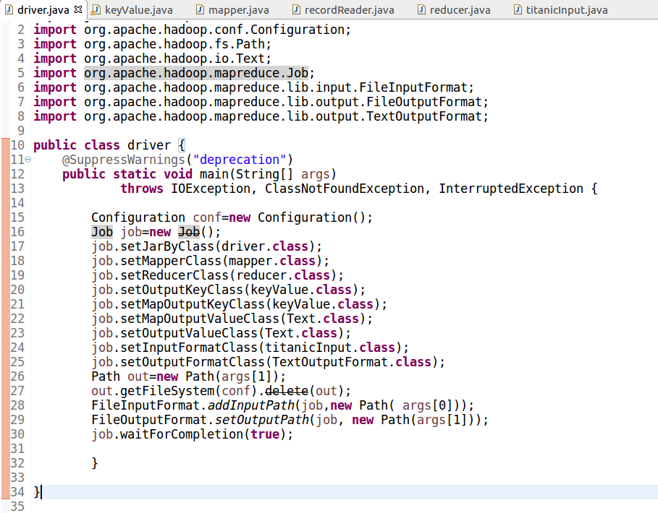

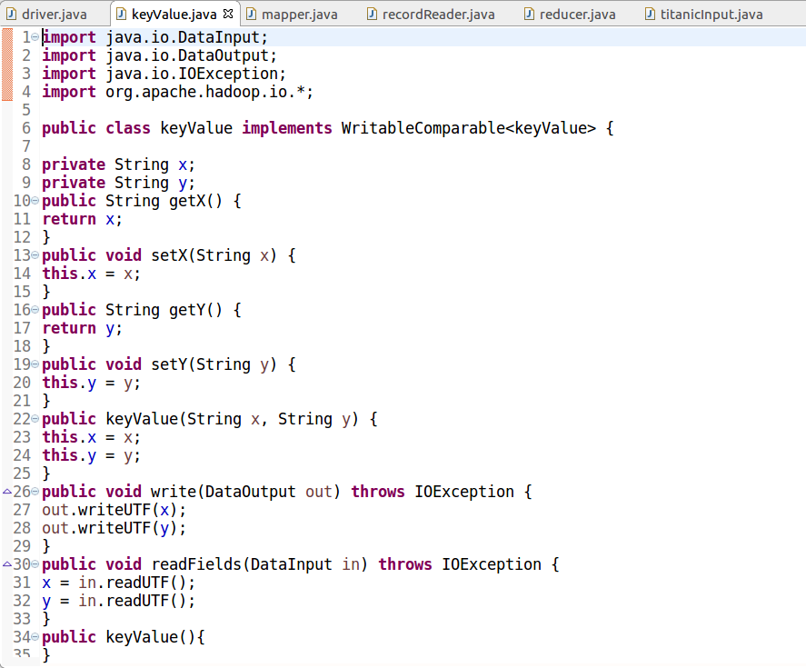

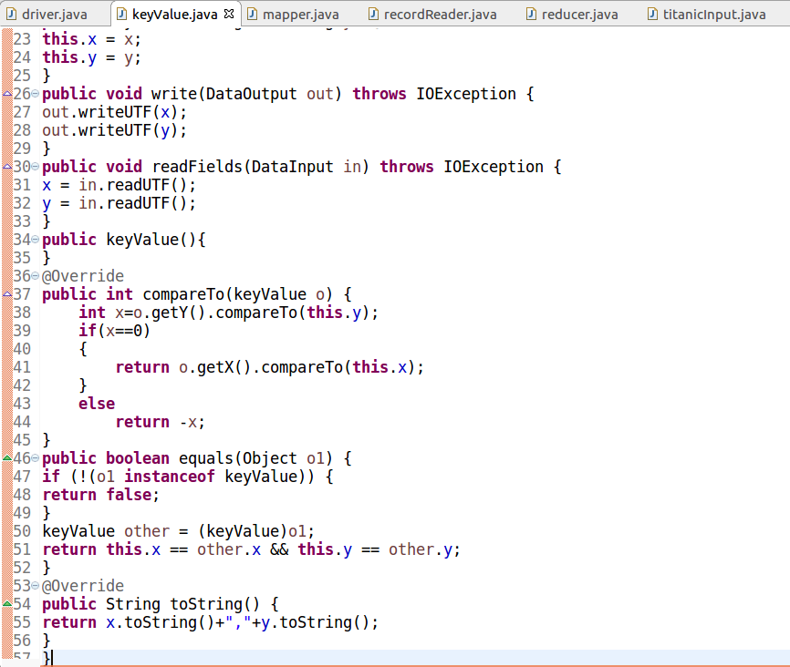

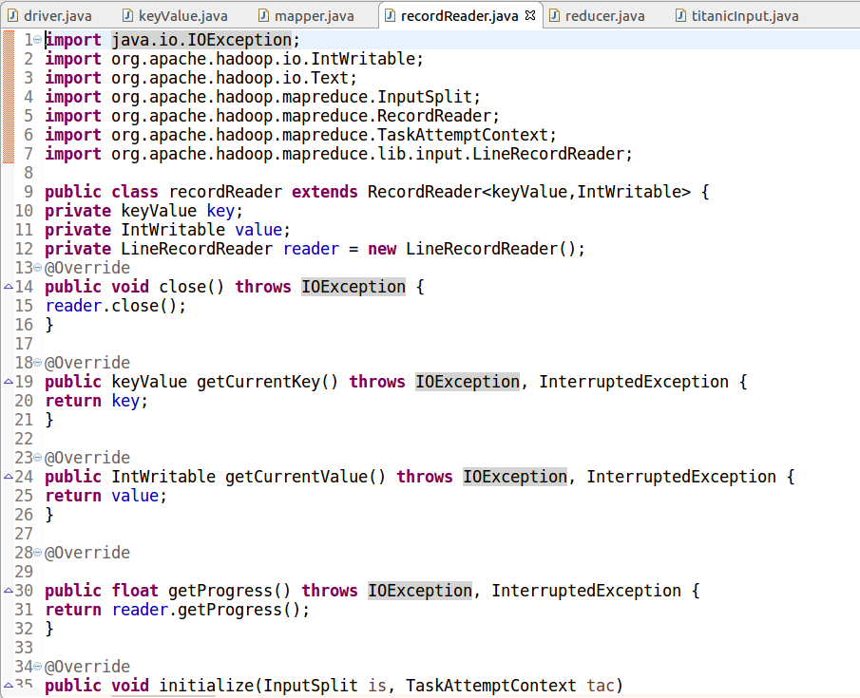

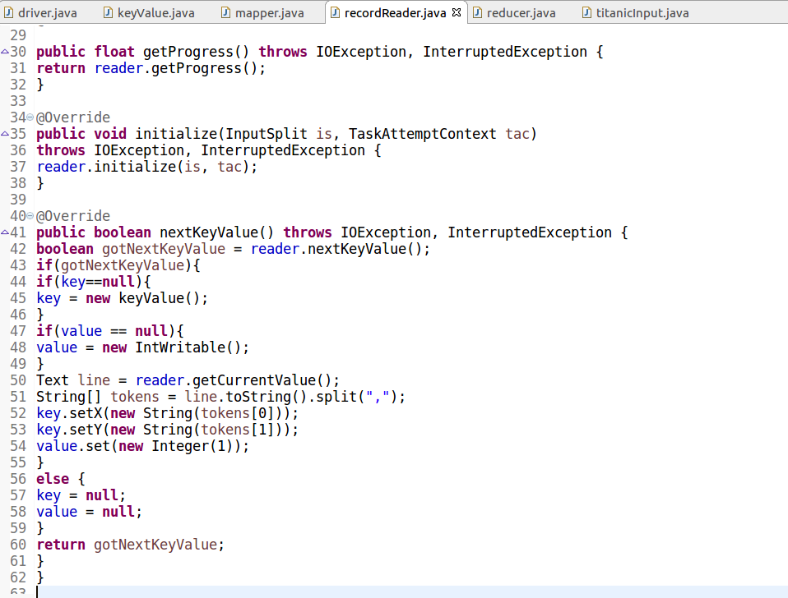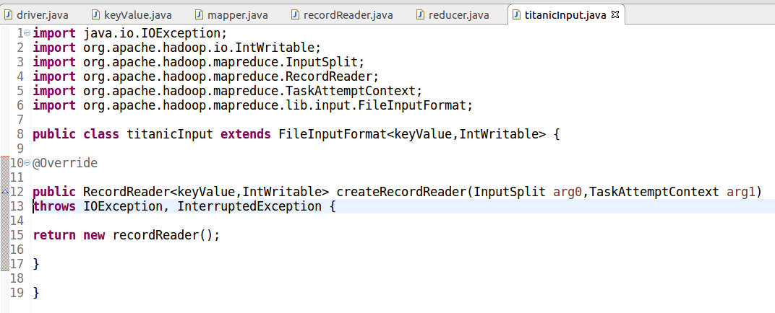

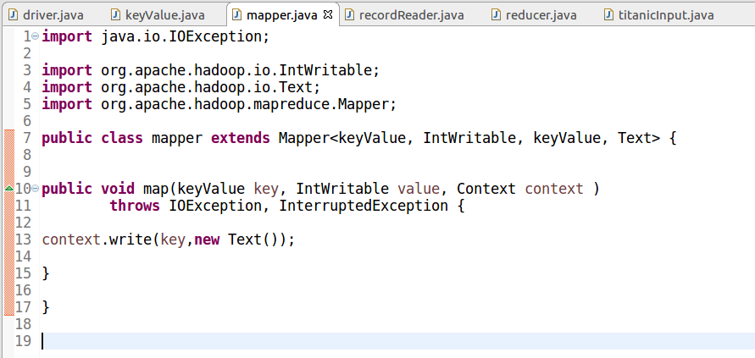

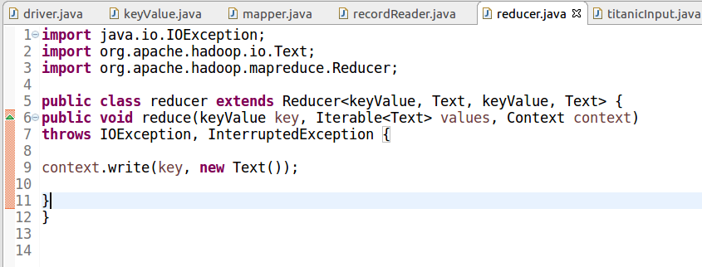

**Output:**

